A Dictionary Based Approach for Gene Annotation
Lior Pachter, Serafim Batzoglou, Valentin I. Spitkovsky, William S. Beebee Jr., Eric S. Lander, Bonnie Berger and Daniel J. Kleitman
Journal of Computational Biology, Vol. 17, No. 7, pp. 634-641, Fall 1999
- Introduction
This paper describes a fast and fully automated dictionary based approach to gene annotation.
A central component of our gene annotation approach is the fragment matching problem. Given a gene and a database, we would like to find all the matches of length k (threshold) or more between the gene and the database.
- Method
- Collect databases of DNA and protein sequence.
- Construct fast lookup dictionary for each database.
- Devise a method to use dictionaries to determine if an unknown sequence has fragments that are like the ones in the databases.
- Use dictionary matches in the context of a dynamic programming algorithm to identify exons.
Using the dictionary to find matches
For a given hit, the following information was returned :
- The position in the input sequence where the hit began.
- The length of the hit. (longer than threshold k)
- The accession number of the target sequence.
- The position in the target sequence where the hit began.
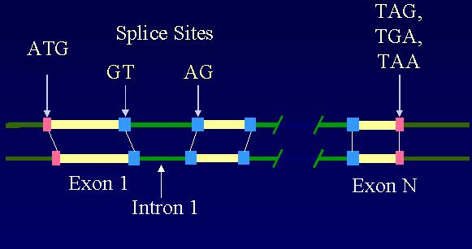
Dynamic Programming
A valid parse was defined to be a subdivision of the gene into coding exons and intorns satisfying the following requirement :
- The coding region begins with the codon ATG.
- The coding region ends with a stop codon (TAG, TGA, TAA).
- All donor splice sites contain the GT consensus.
All acceptor splice sites contain the AG consensus.
- The assigned frames of the exons must be consistent.
The best parse was defined to be the parse with a maximal score (the sum of the scores of the exons).
Score (exon) =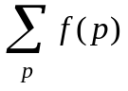
Where p ranges over all the position in an exon. The function f(p)was define by
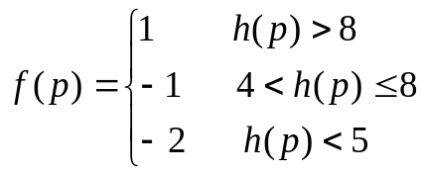
- Results and Discussion
A difficult alignment problem
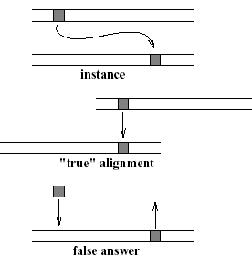
Created by : Jih-Wei Huang
Date : Aug. 6, 2002

